SUCCESS STORY OF ROZA KANDULNA
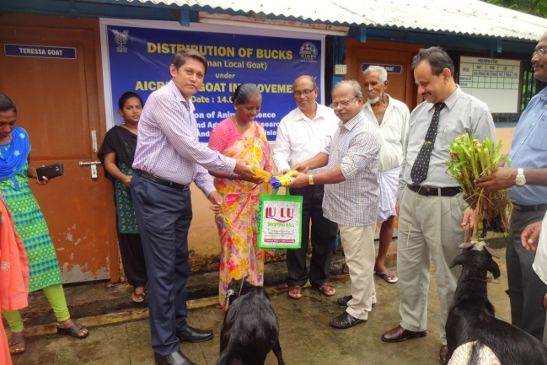
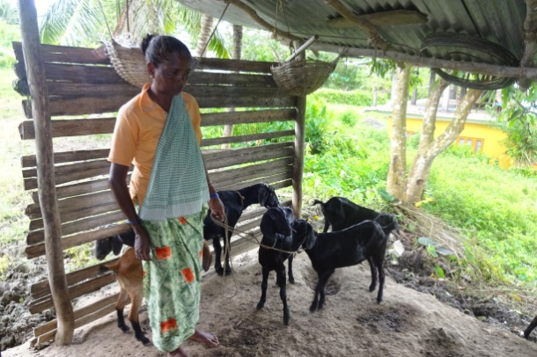
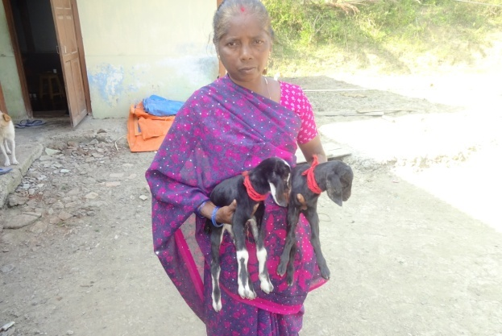
Smt. Roja Kandulna 56 yrs old, a resident of Port mourt village, South Andaman started goat farming with 1 doe 11 years back. She managed goats under a Kaccha goat shelter. She is giving supplemental feed like wheat, rice starch and used to take the goats for grazing and give locally available tree leaves. She recycled the born kids for the expansion of her goat stock. Later she managed to increase the goat stock to 18. With propagation of his goat stock in this manner she is selling 6-7 adult goats and earning Rs. 50000 per annum. ICAR-CIARI is constantly giving technical support for improvement of reproductive performance and health management to enhance her goat population with higher market body weight. She is able to support her family with this source of income as the main part of the earning.
